DS-630 Assignment 2

1. Try a Support Vector Machine regressor (sklearn.svm.SVR) with various hyperparameters such as kernel="linear" (with various values for the C hyperparameter) or kernel="rbf" (with various values for the C and gamma hyperparameters). Don’t worry about what these hyperparameters mean for now. How does the best SVR predictor perform? (based on the housing dataset. i.e., "..\handson-ml2\datasets\housing\housing.csv")

Import pandas to read the CSV file of housing data.

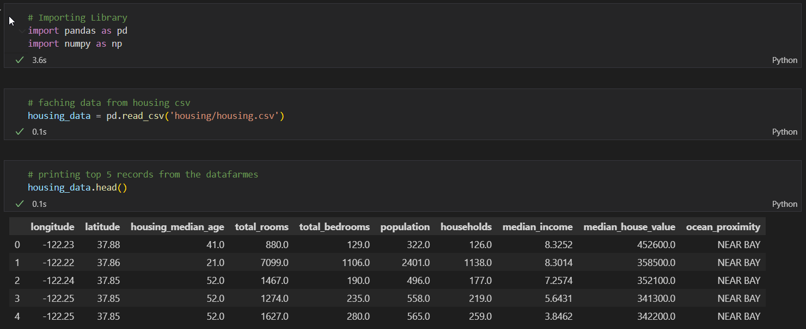



using shape to get the no of rows and columns of the data frame.

And using describe get the count, average, and median of the column’s data.

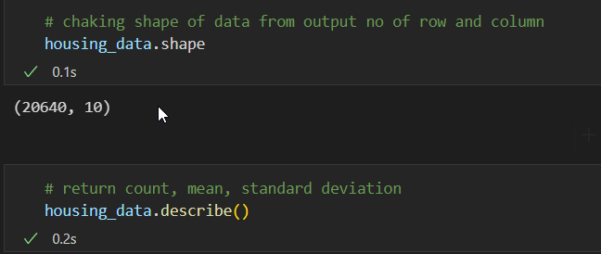

Here importing a matplotlib for plotting the histogram of the data.

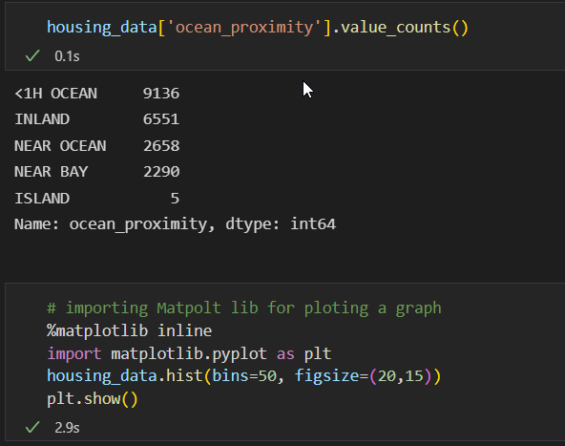

Using this code check the correlation of the column using heatmap.

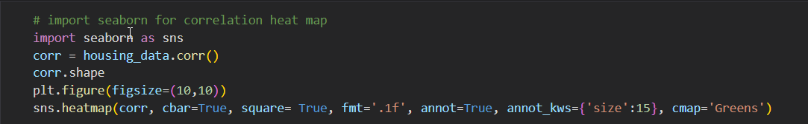

Here making a group Based on Median Income.

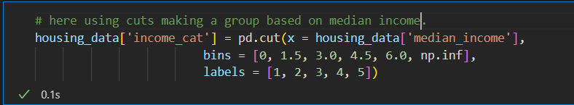

Splitting data into Train(80%) and test(20%) data set using sklearn.

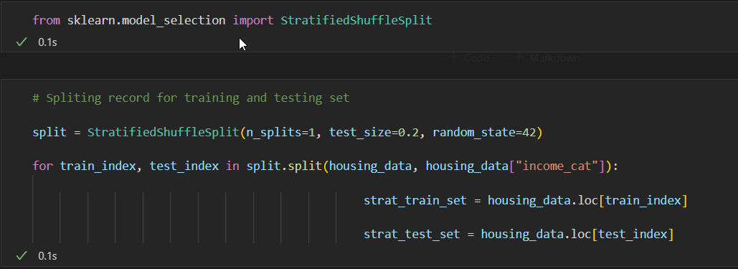

Using this code-making feature engineering for finding how many rooms are needed per household based on total rooms and households. Same bedrooms per room and population pre-household.

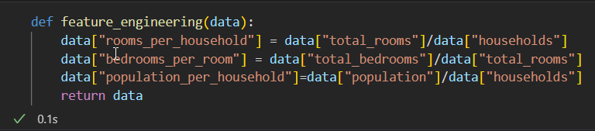

Here I am checking for the null values try to fill the missing value or null value using the median of the data

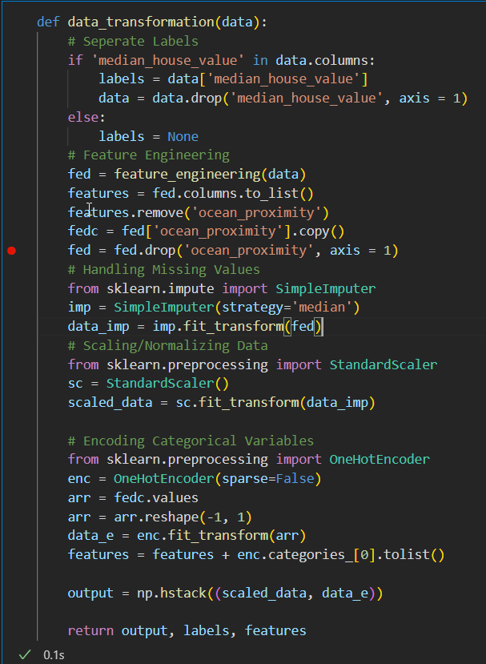

Performing Grid search.

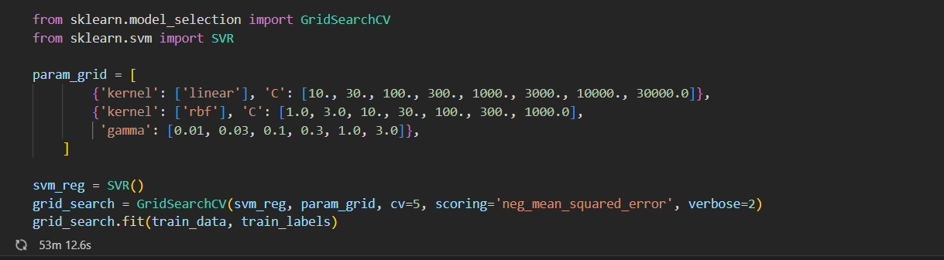

Here is the grid search result in its shows the linear kernel is batter performed batter then RBF

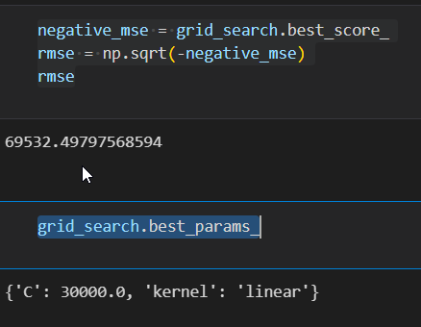

Support vector machine regression works on the principle of the Support vector machine with a few differences. SVR tries to find the curve from a given data point. A curve is used to find the march between the vector and the position of the curve instead of the decision boundary.

1. Try to build a classifier for the MNIST dataset that achieves over 97% accuracy on the test set. Hint: the KNeighborsClassifier works quite well for this task; you just need to find good hyperparameter values (try a grid search on the weights and n_neighbors hyperparameters).

Code:

